Property Repairs Data Analysis Report
By Dermot Madsen
GitHub Repo: Cluid-Housing-Task
1. Overview
This report presents an analysis of a synthetic property dataset to understand total repair costs, and the key factors influencing this feature. The analysis is divided into two sections:
- Descriptive Analysis – summarising the data and understanding distributions.
- Predictive Analysis – building a decision tree model to identify features that drive total repair costs.

2. Objective
- Descriptive Analysis: Explore the dataset, examine distributions, and identify patterns in property repairs, costs, and age.
- Predictive Analysis: Identify which factors most influence total repair costs and assess predictive performance using a Decision Tree Regressor.

- Data Description
Visualisations
To quickly visualise how each numeric variable is distributed, the code uses a list of histograms that plot the 162,500-row count for each feature – Figure 1.
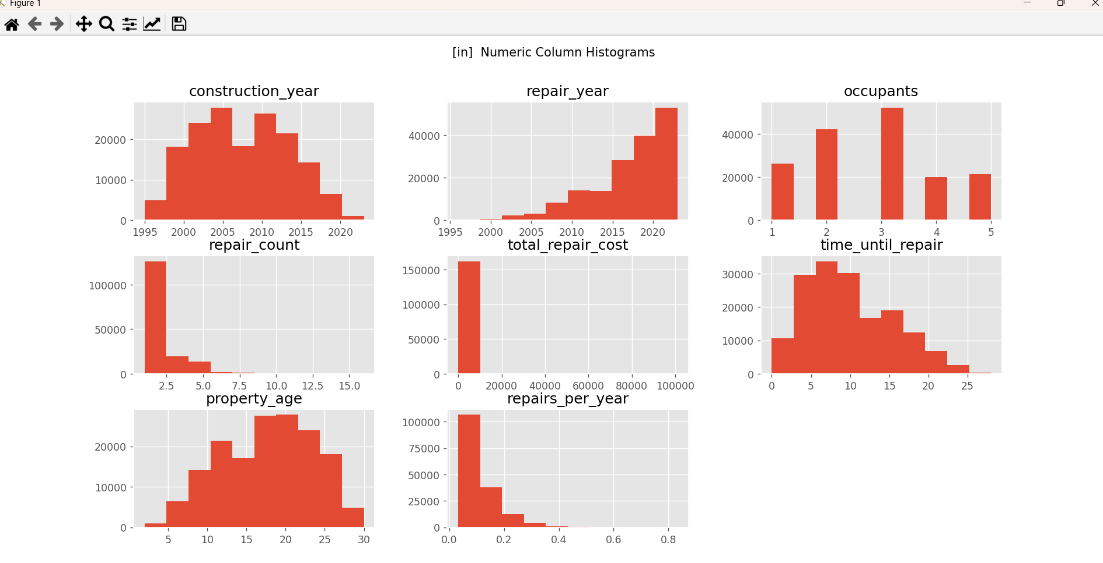
Figure 1- Histogram of variables
Quick Insights:
- Construction Year: Evenly distributed
- Repair Year: Left-Skewness
- Occupants: Evenly distributed
- Repair Count: Right-Skewness
- Time Until Repair: Right-Skewness
- Property Age: Evenly distributed
- Repairs Per Year: Right-Skewness
A skewed distribution can be an indication of the presence of outliers in the dataset. Here in Figure 2. there is an obvious cost repair outlier identified at repair year 2007/2008
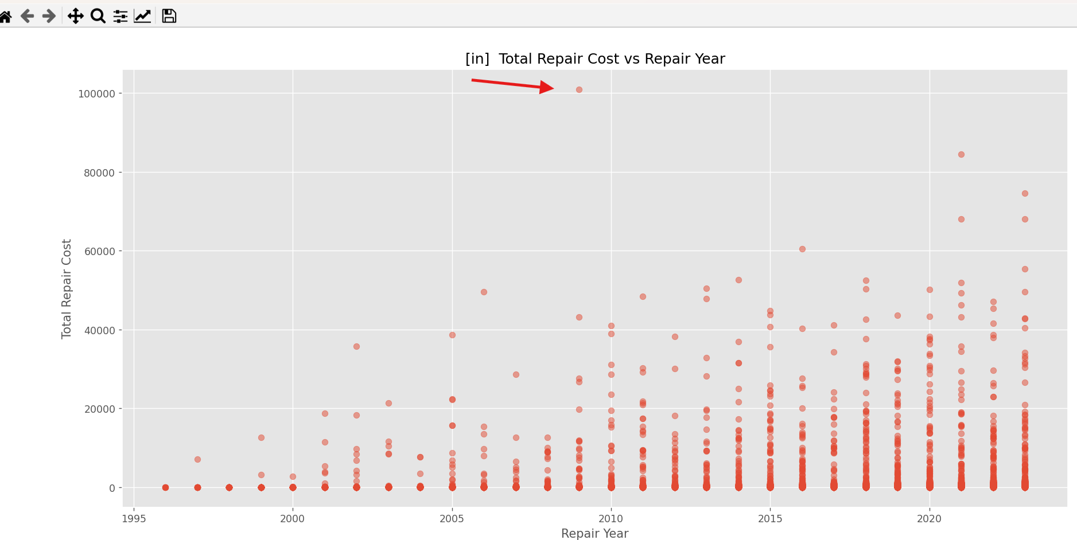
Figure 2 - Scatter Plot Repair Year vs Total Repair Costs

Again, Ther is an obvious outlier visible showing a repair count of 16 repairs in repair year 2016 approximately.
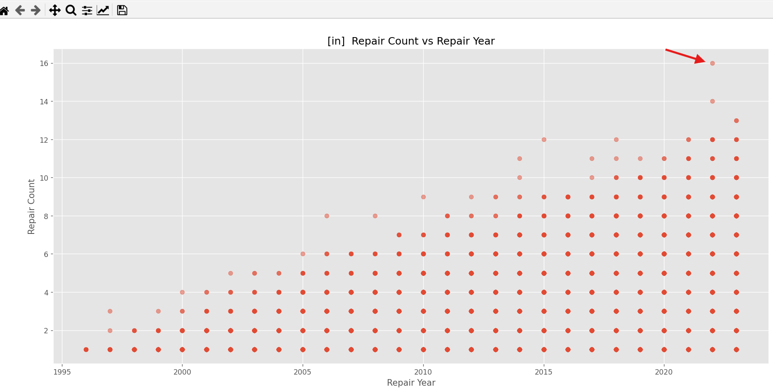
Descriptive Analysis Table
The dataset contains 162,500 properties with the following key numeric variables:
Feature | Count | Mean | Std | Min | 25% | 50% | 75% | Max
construction_year | 162500 | 2007.38 | 5.90 | 1995 | 2003 | 2007 | 2012 | 2023
repair_year | 162500 | 2017.26 | 4.95 | 1996 | 2014 | 2018 | 2021 | 2023
occupants | 162500 | 2.80 | 1.23 | 1 | 2 | 3 | 4 | 5
repair_count | 162500 | 1.88 | 1.27 | 1 | 1 | 1 | 2 | 16
total_repair_cost | 162500 | 134.18 | 1194.63 | 0 | 9.22 | 30.33 | 90.06 | 100988.72
time_until_repair | 162500 | 9.88 | 5.50 | 0 | 6 | 9 | 14 | 28
property_age | 162500 | 17.62 | 5.90 | 2 | 13 | 18 | 22 | 30
repairs_per_year | 162500 | 0.108 | 0.070 | 0.032 | 0.056 | 0.087 | 0.138 | 0.833
Table 1 -Descriptive Analysis Table

Observations from Descriptive Analysis Table:
- Repair Cost Skew: total_repair_cost is highly right-skewed:
  - Mean = 134, Median = 30, Max = 100,989
  - Large standard deviation indicates extreme outliers (heavy tails).
- Repair Frequency Skew: repair_count is also right-skewed:
  - Most properties have 1 repair, but some have up to 16 repairs.
- Property Age: Most properties are 13–22 years old, average 17.6 years.

Correlations between key variables:
Feature | repair_count | total_repair_cost | time_until_repair | occupants | property_age | repairs_per_year
repair_count | 1.000 | 0.690 | 0.410 | 0.314 | 0.253 | 0.786
total_repair_cost | 0.690 | 1.000 | 0.402 | 0.346 | 0.222 | 0.487
time_until_repair | 0.410 | 0.402 | 1.000 | -0.099 | 0.625 | 0.026
occupants | 0.314 | 0.346 | -0.099 | 1.000 | -0.074 | 0.340
property_age | 0.253 | 0.222 | 0.625 | -0.074 | 1.000 | -0.302
repairs_per_year | 0.786 | 0.487 | 0.026 | 0.340 | -0.302 | 1.000
Table 2 - Correlation Table

Key Insights from Correlation Table:
- repair_count and repairs_per_year are strongly correlated with each other and with total_repair_cost.
- time_until_repair and occupants show moderate correlation with costs.
- Property age is moderately correlated with time until repair but has a weaker effect on cost.

4. Predictive Analysis
4.1 Objective
To identify which features are most influential in predicting total repair costs using a Decision Tree Regressor.
4.2 Methodology
- Features Used: repair_count, time_until_repair, occupants, property_age, repairs_per_year
- Target Variable: total_repair_cost (log-transformed to reduce skew)
- Model: Decision Tree Regressor with max_depth=5
- Evaluation Metric: Root Mean Squared Error (RMSE) on original cost scale
4.3 Results
Correlation Summary:
- Strongest correlations with repair cost: repair_count (0.69) and repairs_per_year (0.49)
- Moderate: time_until_repair (0.40), occupants (0.35)
- Weak: property_age (0.22)
Decision Tree Performance:
- RMSE (original scale): 94.84
Feature Importance:
Feature | Importance
repair_count | 0.798
time_until_repair | 0.118
occupants | 0.084
property_age | 0.000
repairs_per_year | 0.000
Interpretation:
- Repair count is the primary driver of repair costs.
- time_until_repair and occupants provide minor contributions.
- property_age and repairs_per_year do not improve the model significantly.

5. Conclusion
- Descriptive Analysis:
  - Repair cost and repair frequency are highly skewed, with most properties having low costs and few repairs, but with heavy right tails.
  - Strong relationships exist between repair_count and total_repair_cost.
- Predictive Analysis:
  - A Decision Tree Regressor confirms that the number of repairs is the dominant factor influencing total repair costs.
  - Other variables have minor effects, and some (like property_age or repairs_per_year) do not improve predictive power.
Recommendation:
- For predicting or managing repair budgets, focus primarily on repair frequency.
- Consider handling outliers and skewness in cost data when building more advanced predictive models.

